**National Multicultural Interpreter Project**

**Cultural and Linguistic Diversity Series**:

“Life Experiences of

Victor Vodounou

Benin-Africa”

Recorded on

February 27, 1998

at El Paso Community College

El Paso, Texas

Total Running Time: 22:30

Instructional Supplement

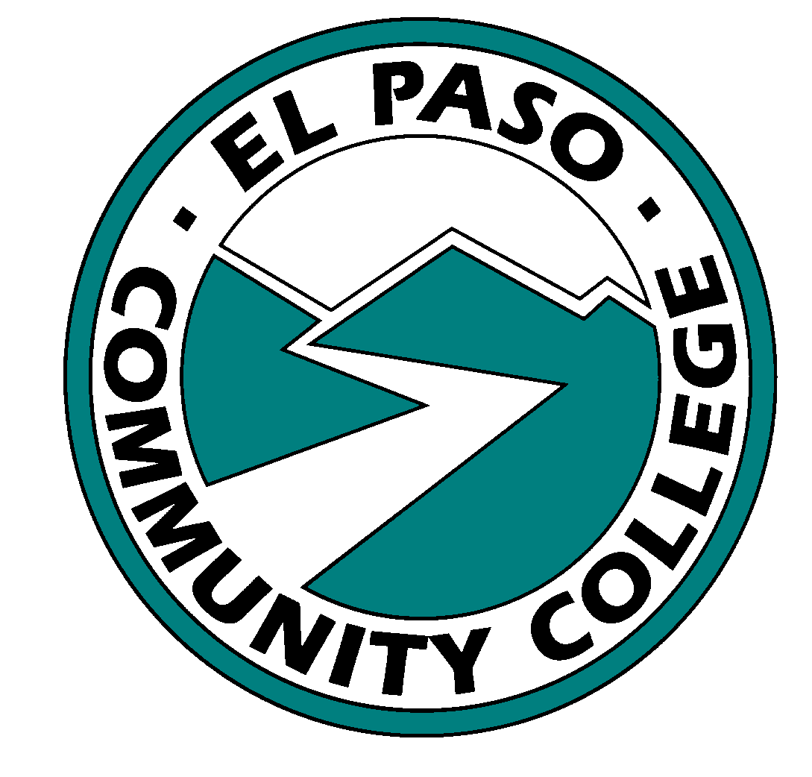



**Video Project Produced By:**

**National Multicultural Interpreter Project**

**El Paso Community College**

**P.O. Box 20500**

**El Paso, TX 79998**

**915-831-3187 V/TTY**

**915-831-2095 FAX**

**E-Mail: nmip@epcc.edu**

**www.epcc.edu/Community/NMIP/Welcome.html**

***ACKNOWLEDGMENTS***

**National Multicultural Interpreter Project**

We would like to express our appreciation to Victor Vodounou for his generous contribution and all the other presenters, cultural consultants and staff of the National Multicultural Interpreter Project for their great efforts in making this videotape series and all other NMIP projects possible.

Special Production Credits to:

El Paso Community College

Center Instructional Telecommunications Staff

Mary L. Mooney, Project Director

and Instructional Supplement Developer

Thaddeus Cunejo, Graphics/Editor

Eduardo Molina, Post-Production

Alma Patricia Delgado, Transcription

Isabel Baca, Technical Editing

Transcript and accompanying videotape were produced with funds from the United States Department of Education, NMIP National Multicultural Interpreter

Project - Grant #H160c50004, at El Paso Community College, El Paso, TX.

The contents do not necessarily reflect the policies or opinions of EPCC, NMIP or the federal government.

Publication date August 30,2000.

Copyright © 1999 by El Paso Community College. All rights are reserved.

Table of Contents

Transcription and Editing Notes Page 2

Suggestions for Use of This Videotape Page 2

Instructional Uses for the Material Page 3

Introducing or Extending the Activity Page 4

Multicultural Resource Materials Page 5

Additional Training ResourcesQuestion - How Did Andrew Foster Find You in Africa? Page 6

Question: Do You Have Any Stories from Africa? Page 9

Question: What Do You Miss Most From Benin? Page 11

Question: What Differences Do You See Between Africans and African Americans? Page 12

Question: What Are Your Experiences with Interpreters? Page 13

**A Culturally Infused Lecture:**

**“Life Experiences of Victor Vodounou - Benin-Africa”**

Transcription and Editing Notes

Victor Vodounou presented on his life experiences on this topic extemporaneously. The transcription has attempted to incorporate the natural speaking style and register of the speaker. This lecture was presented and videotaped without breaks. Some prompting questions “off camera” were asked of Mr. Vodounou; these have been inserted as captions. The lecture has been edited. The transcription editors have inserted sentence, paragraph and/or video pauses. Information in [ ] indicates a cultural expansion. It is not intended to reflect any discourse style, but rather a place for class discussion for instructional usefulness without damaging the tape. Some words and phrases that carry specific cultural connotations and denotations are bolded when first introduced. Viewers are encouraged to explore the connotations and denotations in context.

Mr. Vodounou’s voice is included on the tape. The written script transcriptions are meant as a general guide to potential meaning and interpretation choices in English.

Suggestions for Use of This Videotape

This videotape contains embedded cultural identity and cultural information regarding an individual of African birth and heritage. The material is an individual’s life story and reflects contrasts to the life experiences of African American and/or Black individuals from the United States and other places of origin. This video would be a valuable addition to American Sign Language, Deaf Culture and interpreting classes.

The presenter’s first languages are Fon and French. The presenter’s discourse style is reflective of an individual who has learned American Sign Language as second language. It heightens awareness of the linguistic accomplishments of many foreign born deaf individuals who are multilingual and multicultural and for whom ASL and English may be third or fourth languages.

The videotape lends itself to a discussion of the African versus Black US experiences, cultural traditions and heritages. The presenter begins with an introduction of self and his country of Benin. He then shares the significant work of Andrew Foster in assisting him personally and providing services to the deaf in Africa. It illustrates some of the common themes in early identification of deafness, parental concerns and efforts to locate educational resources. The interview emphasizes the importance of the interpreter’s familiarity with the great diversity within the general values, beliefs and cultural knowledge and traditions of African American and Black peoples from around the world.

In developing cultural literacy, Sherry Shaw from the University of Arkansas at Little Rock, has produced an excellent guide, utilizing expansion techniques, for acquiring “cultural” knowledge as the basis for skill development and an improved interpretation. These techniques are directly applicable to many multicultural situations.

Instructional Uses for the Material

**Attending/listening/visualization skills**

Use as text for mind-mapping techniques to encourage text analysis, visual spatial, and ASL skills.

* Have students record major ideas and details by drawing or using symbols.

· Have students identify and discuss the major cultural themes of the lecture.

**Cultural vocabulary in context**

Have students make a list of all the cultural terms that would have various connotative or denotative meanings from an African, African American, and /or Black perspectives.

* Compare the list with the annotated script.
* Discuss similarities and differences of perceptions.
* Discuss the use of cultural terms and signs for concepts that respect the cultural and linguistic integrity of the African signer’s perspective.
* Compare and contrast with the non-African perspectives or connotations.

Examples: alligators versus crocodiles, extended family, herbal remedies

**Cultural implications of use of space**

Discuss how the use of space, classifiers, and referents can indicate cultural differences to an audience.

Discuss how those features can be used to show equal but different and not “inferior” status of groups; for example, the use of comparative and contrasting structures, such as African perspectives’ to U. S perspectives’, African culture and American culture, languages used, identities of African America or Black versus African; and as a way of showing respect.

Discuss how the use of space and referents is used to emphasize a change in location and the use of geographical referencing is used to trace the movement of people and ideas.

**Cultural impact on text analysis**

Discuss the communication goals of the speaker.

Discuss the choices for cultural “dynamic equivalence” for sign to voice interpreting of the bolded words and phrases.

Discuss the utilization of interpreting strategies such as the vocal inflections

used within different cultural communities, ie. African American, Black, African.

Discuss the signing and vocal accents of foreign -born signers.

Discuss the use and appropriateness of cultural expansion techniques for both non-Deaf and non-African audiences.

Discuss the discourse organization and signing pace of the anecdotes.

Does it seem fast paced, or slower paced compared and contrasted to other cultural signers or than the local or regional style?

Introducing or Extending the Activity

Invite local hearing and Deaf multicultural representatives from your community to relate their own stories or other cultural information regarding their immigrant experiences to your community.

Investigate further the life and contributions of Andrew Foster and other individuals from cultural and linguistic diversity.

Have an different speakers from other African nations discuss the their histories and culture.

Have in class or student assignments to do a similar discourse and cultural text analysis process to other video or live presentations.

Multicultural Resource Materials

The video selection, Eli Shepards’ “Plantation Songs”, with an introduction by Barbara Hardaway, this is a collection of musical folklore, monologues, love ballads, and spirituals presented as a testament to the oral traditions of African Americans at the turn of the centruy in rural America.

The “Class of 52" is a historical documentary that explores the segregation o and struggle of black children to gain admittance to Kendall School on the campus of Gallaudet. Videotape - 43 minutes

Available from Gallaudet University Department of Television, Photography, and Educational Technology. 800 Florida Avenue, NC, Washington, DC 2002-3695. Telephone 202-651-5113/5115 V/TDD and 202-651 5124 FAX.

Carroll, C. and Mather S. M. (1997). Andrew Foster: bringing hope to the world. In Movers and shakers: deaf people who changed the world. (pp. 45-50). San Diego, California: Dawn Sign Press.

Hairston, E. and Smith, L. (1983). Dr. Andrew Foster. In Black and deaf in America: are we that different. (pp.66-67). Silver Spring, Maryland: T J Publishers, Inc.

NMIP Web site: www.epcc.edu/Community/NMIP/Welcome.html for additional bibliography and resources.

Additional Training Resources

Shaw, S. (1997, July). Cultural Literacy for Interpreters. VIEWS, 14, 1, 41.

Sherry Shaw, M.Ed., CSC, Instructor, Materials Development Specialist

RSA Region VI Interpreter Training Project

University of Arkansas at Little Rock

2801 S. University

Little Rock, AR 72118

501-569-3169

Email: slshaw@ualr.edu

Lawrence, S. (October 1996) CIT Newsletter and Tenth National

CIT Proceedings.

Question - How Did Andrew Foster Find You in Africa?

My name is Victor Vodounou, my sign name is “V” on the chest. When I was born and grew up in **Benin** – it’s small country in **West** **Africa** near **Nigeria**. It is a French speaking country. We spoke French in school and for business. It was the official language, but at home, we used many different languages -- about 50. There are many different **tribes**, and each tribe speaks a different language, at work or school. My tribe’s name is **Fon**. It is the largest tribe in Benin. In the south-central area of Benin, there are many different tribes.

I was born -- I’m not sure if I was hearing or deaf, but -- I went to school. Growing up, I was in public school. I went to different classes and the teachers there – the teachers there, it’s a stricter there, punished me all the time. They didn’t know why I was making mistakes. Later they found out I was deaf, by then, I was nine.

My parents didn’t know why I was deaf. But they tried and tried to restore my health so I could hear again. They put **herbal medicines** (ground leaves) in my ears to restore my hearing. Sometimes they work, but it didn’t work for me. I met a French doctor who tried to help – he gave me shots, and ear drops, and a hearing aid but that didn’t help. My hearing was fading away; my vision was fading away, everything was shutting down, but the French doctor saved my life. He gave me many injections. My vision was affected. I could talk again, but it was still hard to hear. But that was fine with me.

So I went to a regular school, but I couldn’t continue in school. There was no program for the Deaf, no residential school for the Deaf. So I stayed home on the farm and fished. It was a big **tribal family** and they were all farmers and fishermen.

So, I learned to fish and farm, until I met a deaf man from America, here “in Africa.”

His name was **Andrew Foster**. He is a Black African-American. He was the first (African American) deaf person to graduate from Gallaudet University and go to Africa to teach the deaf people. He was looking for me. I was hard to find in the deep **jungle**. He found me and that was the first time I met a deaf person. I thought I was the only deaf person in the world. But that’s not true! I met Andrew. His sign name is “A” by the ear.” He showed me that he was **Deaf, like me.** He and his wife were both deaf. He showed my parents and they understood. He thought that he could help me. I could go with him to his home in Nigeria. He taught me English; he taught me the Bible; and he taught me how to sign. That’s how I encountered signing.

So, I stayed with him. It was a wonderful experience, his teaching me. It helped me later to go back to Benin and start a small deaf school. So now, we have one deaf school in Benin. In the past there was nothing. Andrew encouraged me to finish high school, so I tried and tried, it was hard. But I finished high school. Then I taught the deaf children there – they said you need a college degree. But I couldn’t find the money, but there was an organization here in American that helps, **Rotary** **Club**. They paid for me to go one year to Canada for college. Because my country speaks French, they sent me to French Canada. So I got money to get my B.A. in special education. I went back to Benin because I still wanted to teach deaf people. So I tried and tried and I moved back to America in 1990. I went to NTID [the National Technical Institute for the Deaf] in Rochester, New York. I graduated with my degree in Deaf Education.

I found a job at California School for the Deaf in Riverside for a year. Then I moved to Texas, El Paso, Texas, here, to work with the church - a deaf church here with “DC” [namesign] Don Cabbage who is a pastor. Don invited me to come here and work with him here in El Paso for two or three years. I heard about a program in New Mexico. I started to attend New Mexico State University. It was hard commuting back and forth, so I moved to New Mexico and now I live in New Mexico.

My goal is to go back to Africa and help the deaf people there. How I will help is to establish a technical and high school program for the deaf people there. Now all over (Africa) when deaf people finish elementary school, what happens . . . they get a job and learn on the job. You can earn a living, but that’s not enough. You can get by, but where is their goal?

Question: Do You Have Any Stories from Africa?

Life in Africa is so different. Deep in the jungle where I was born, I lived near a lot of animals, there were **lions, elephants**, **crocodiles**, and **hippos**. In the village, there are many hippos, it is hard to shoot them. The village people kill them to supply six months worth of meat, then you don’t have to buy meat. The lions don’t hurt the people, unless you bother them. So if you disturb them, just be ready to save yourself! The people grab them [crocodiles] and eat them fast – the crocodiles. My father used to catch them – used to grab them by the tail, and hold them by the tail, they were stuck and couldn’t move.

There are other animals, that are more dangerous, in that area near the tribe. **Boas**, they are really big snakes – they eat people. They stay coiled in the tree and when a person comes near by, they drop on them. Then they start coiling around the person and start constricting and eating the person from the feet first and move up to the head. It is a tough situation. If you are lucky to be alive by the time the snake reaches the head -- one can still yell for help. Maybe someone can come and save you and slice open the snake so you can escape – if you haven’t died yet.

The hippos, they don’t eat people, but they often kill them. When they are near the boat, they will turn the boat over in the water. The people fall into the water and the hippo holds them down with its feet under water and they can’t escape. They don’t eat the people, but they do drown them. You can yell, but it is hard to yell from under the water, because the hippo can get you also. It is dangerous, but it won’t eat people, just grass – but it will kill you by holding you down or biting you. It will die if you shoot it in the chest, but it won’t die if you shoot it in the head or on other parts of the body. Hippo meat tastes good!

It’s sad, but animals are starting become extinct in Africa -- they are being killed for food. But another reason is that they are selling elephants for their ivory, not for the food. Instead they are killing them for the purpose of selling the elephants’ ivory in Europe. They buy the teeth, the ivory, not the meat, for business. Here in the U. S., the alligator skin is valuable. I don’t know why. My father used to throw away the skin. He would make **drums** with skin, but I don’t know why it is so valuable here. A friend told me the skins are important in America to make shoes.

America is a fast- growing industrialized country, Africa is slowly developing, it is not the same. Life is different in America. (In Africa) the **extended** **families** – **cousins**, are all together, we eat all together, we cook all together. We take food to our parent’s or uncle’s house – always all together. **Men and women eat separately**. My wife and I used to eat separately, but with western influence we eat together. Now it is different. In Africa, we work together and we are near each other. Here it is hard, to be with the family. We live far from each other. We can’t walk there. So if we arrive and if no one’s there, what do we do? It is different.

Question: What Do You Miss Most From Benin?

I miss my family, the culture, my friends and African food. I moved here; there are different foods, different customs. The food here is more spicy, with more pepper and salt. When I moved here, many of the foods here are different; many of them are very sweet. It is very difficult, very different. Another example is teeth cleaning. **Here I make an appointment with a dentist to clean my teeth** . In Africa no one goes to the dentist. You use pieces of wood to get your teeth really clean. So it’s a different culture.

America is so big! I don’t have any other friends from Benin with whom we can talk our language. So when we moved here, we spoke our language, but now with our children, they don’t understand the African language now. It’s fading away. English is taking over. My wife and I are still speaking our language. It still influences us.

I’m happy with the Deaf Culture here in America, and associating and socializing with the deaf people of El Paso and New Mexico. Deaf culture is changing so much, but Africa changes as well.

Question: What Differences Do You See

Between Africans and African Americans?

From my experience and observations, there’s a big difference between Black people born in Africa and Black people born here in America. The difference is – for example, if we are born over there we know where **we are from** . . . we know our **connection** to our tribal people. **Those who are brought** here a long time ago, have lost that connection and it influences them.. When I meet **European Americans**, they know their heritage, but African Americans don’t know exactly in Africa where they are from, and it’s a problem in the culture. But in politics, economic systems, and educational systems there are vast differences. That’s my opinion.

Question: What Are Your Experiences with Interpreters?

I wish we had interpreters in Africa, but we don’t have programs for interpreters. I’m not sure that there’s work for interpreters in Africa. But in America there are many interpreters. They have interpreted for me. I wish that they would understand my needs and my cultural issues, but I haven’t yet had an African interpreter with me. I don’t know if I could find one or how I’d feel.